CS499  
Senior capstone project

The Legend of Zelda: Dungeon Warrior

Software Design Document

Version 1.0

Randall Rowland

18 July 2016

# Revision History

|  |  |  |  |
| --- | --- | --- | --- |
| Date | Version | Description | Author |
| 29 June 2016 | 1.0 | Initial version of The Legend of Zelda: Dungeon Warrior’s Software Design Document | Randall Rowland |
|  |  |  |  |
|  |  |  |  |
|  |  |  |  |
|  |  |  |  |
|  |  |  |  |
|  |  |  |  |

C

ontents

Revision History ii

1. Introduction 1

1.1. Purpose 1

1.2. Goals and Objectives 1

1.3. Definitions, Acronyms, and Abbreviations 2

1.4. References 2

1.5. License 2

2. Design Overview 4

2.1. Introduction 4

2.2. Technologies Used 4

2.3. System Architecture 4

2.4. System Interfaces and Operation 5

2.5. Constraints and Assumptions 5

3. User Interface Design 6

3.1. Description of the User Interface 6

3.2. Interface Design Rules 7

3.3. Objects and Actions 7

# Introduction

The Software Design Document is a document to provide documentation which will be used to aid in software development by providing the details for how the software should be built. Within the Software Design Document are narrative and graphical documentation of the software design for the project including sequence diagrams, collaboration models, object behavior models, and other supporting requirement information.

## Purpose

The purpose of this software design document is to provide a low-level description of The Legend of Zelda: Dungeon Warrior, providing insight into the structure and design of each component. Topics covered include the following:

* Class hierarchies and interactions
* Data flow and design
* Processing narratives
* Algorithmic models
* Design constraints and restrictions
* User interface design
* Test cases and expected results

In short, this document is meant to equip the reader with a solid understanding of the inner workings of The Legend of Zelda: Dungeon Warrior.

## Goals and Objectives

The Legend of Zelda: Dungeon Warrior is a single, comprehensive programming project using the C++ programming language. The goal is a proof of concept program to demonstrate learning objectives learned throughout American Sentinel University’s Bachelor of Science in Computer Science Game Programming Specialization degree program. The Legend of Zelda: Dungeon Warrior will incorporate the learning objectives from:

* CS130 – Introduction to Computer Programming
* CS205 – Intermediate Computer Programming
* CS221 – Software Engineering
* GP210 – Introduction to Game Design
* GP221 – Introduction to Game Programming
* GP312 – Computer Graphics Programming
* GP435 – Artificial Intelligence for Gaming

The objectives of The Legend of Zelda: Dungeon Warrior:

* Apply software engineering techniques to a larger-scale problem
* Integrate appropriate computer science theory, concepts, and methods
* Demonstrate proper documentation
* Display comprehensive programming knowledge

## Definitions, Acronyms, and Abbreviations

* **AI** – Artificial Intelligence.
* **Object** – Is a data structure that has state (data) and behavior (code). Objects correspond to things found in the real world.
* **OOP** – Object Oriented Programming. Programming language model organized around objects rather than “actions” and data rather than logic.
* **Scholarship** – Academic study or achievement; learning of a high level
* **UML** – Unified Modeling Language. For definition and uses, see <http://www.uml.org/what-is-uml.htm>

## References

Christopho. (2016, January 25). Zelda ALTTP resource pack for Solarus. Retrieved June 29, 2016, from <https://github.com/christopho/solarus-alttp-pack>

Morrison, M. (2005). Beginning game programming. Indianapolis, IN: SAMS.

## License

### Software Design Document/Source Code License

This document and the source code for The Legend of Zelda: Dungeon Warrior are licensed under a [Creative Commons Attribution-NonCommercial-ShareAlike 4.0 International License](https://creativecommons.org/licenses/by-nc-sa/4.0/legalcode).



Under this license, you are free to:

* **Share** – copy and redistribute the material in any medium or format
* **Adapt** – remix, transform, and build upon the material

Under the following terms:

* **Attribution** – You must give appropriate credit, provide a link to the license, and indicate if changes were made. You may do so in any reasonable manner, but not in any way that suggest the licensor endorses you or your use.
* **NonCommercial** – You may not use the material for commercial purposes.
* **ShareAlike** – If you remix, transform, or build upon the material, you must distribute your contribution under the same license as the original.

### Zelda: A Link to the Past Copyright

The Zelda fonts, music, sounds, sprites, tile sets, and other resources used from Zelda: A Link to the Past are copyrighted and owned by Nintendo.

As The Legend of Zelda: Dungeon Warrior is for scholarship, these resources fall under Fair Use. For this particular instance. However, if the project is shared outside of educational purposes or for commercial use, these resources must be removed.

17 U.S. Code § 107 - Limitations on exclusive rights: Fair use

Notwithstanding the provisions of sections 106 and 106A, the fair use of a copyrighted work, including such use by reproduction in copies or phonorecords or by any other means specified by that section, for purposes such as criticism, comment, news reporting, teaching (including multiple copies for classroom use), scholarship, or research, is not an infringement of copyright. In determining whether the use made of a work in any particular case is a fair use the factors to be considered shall include—

(1) the purpose and character of the use, including whether such use is of a commercial nature or is for nonprofit educational purposes;

(2) the nature of the copyrighted work;

(3) the amount and substantiality of the portion used in relation to the copyrighted work as a whole; and

(4) the effect of the use upon the potential market for or value of the copyrighted work.

The fact that a work is unpublished shall not itself bar a finding of fair use if such finding is made upon consideration of all the above factors.

# Design Overview

## Introduction

The Design Overview is section to introduce and give a brief overview of the design. The System Architecture is a way to give the overall view of a system and to place it into context with external systems. This allows for the reader and user of the document to orient themselves to the design and see a summary before proceeding into the details of the design.

## Technologies Used

### Hardware

* Hewlett-Packard ProBook 640G1
  + Intel® Core™ i3-4000M
  + 8 GB Ram
  + Windows 7 Enterprise SP1 (64-bit)
* Lenovo X1 Carbon
  + Intel® Core™ i7-5667U
  + 8 GB Ram
  + Ubuntu 16.04 LTS (64-bit)
* Alienware Mx11-R2
  + Intel® Core™ i7
  + 8 GB Ram
  + Windows 7 Home Edition SP1 (64-bit)
* Custom Desktop PC
  + AMD Phenom
  + 16 GB Ram
  + Ubuntu 16.04 LTS (64-bit)

### Software

* Microsoft Visual Studio
* Microsoft Visual Studio Code
* Microsoft Office 2016 Professional Plus
* Atlassian SourceTree
* Pinta 1.6
* Microsoft Word 2013
* Syntevo GmbH SmartGit 7.1
* Dia 0.97.3
* Geany 1.27
* Tiled Map Editor 0.16.1

## System Architecture

## System Interfaces and Operation

## Constraints and Assumptions

# User Interface Design

## Description of the User Interface

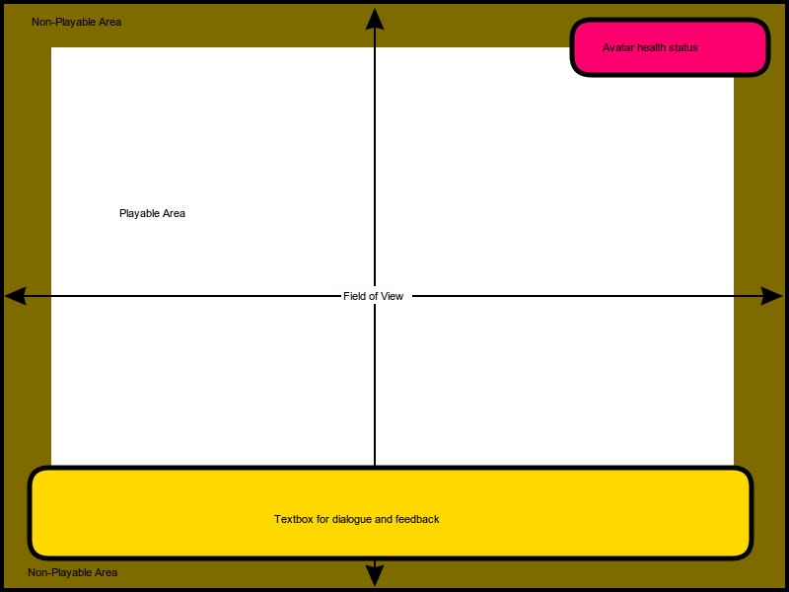

This is a general layout of how the user interface will look. Proportions may not be exact in the final product. End user will interact with the user interface and avatar using the arrow keys and space bar on the keyboard. **Field of View:** Inside of the Field of View will be a set size and the end user will not be able to change the size to ensure correct aspect ratio and view. Field of View will be contained within the Window and will not scroll.  
**Non-Playable Area:** Inside of that window will be a border. Border will use wall type graphic to give the illusion the avatar is in a room. This is depicted above with the brown/bronze color and labeled as a Non-Playable Area. This will stop the avatar from “walking” off the screen. Although depicted all the way to the edge of the Field of View, this is only an example. Some levels may be smaller and have a smaller Playable Area.  
**Playable Area:** The avatar will be able to move anywhere within the white area or Playable area. Border will prevent avatar from accessing non-playable areas. EXCEPTION: Elements may be added to the playable area to give an aesthetic look and challenge the avatar. The avatar may or may not be able to “walk” through those elements.  
**Textbox:** This portion depicted with the yellow/gold box above will not be visible all the time. This will be a popup box when the avatar is interacting with other entities. When this popup box appears, all elements within the Playable Area will pause. The main focus will be on the textbox and the end user will only be able to interact with the textbox until it is complete and goes away. Then the Playable Area will resume normal game play.  
**Avatar Health Box:** The pink box depicted in the top right corner will be sometime of floating health meter to provide the avatars health status to the end user. This will be visible at all times during game play.

## Interface Design Rules

The interface design rules for The Legend of Zelda: Dungeon Warrior are derived from Ben Shneiderman’s “Eight Golden Rules of Interface Design”. The following list offers a description of each rule, as well as how the rule applies to The Legend of Zelda: Dungeon Warrior.

## Objects and Actions